# Logic

* Read the excel datasheet as a pandas Dataframe
* Fill all null (NaN) values with ‘0’.
* Remove the unnecessary index rows and columns • Convert the dataframe to NumPy adjacency matrix.
* Create a networkx graph and using the adjacency matrix
* Create a dictionary to store the count of nodes visited.
* Start with a random node
* Loop 1-100000 o Choose a random node to visit from the outgoing edges of the current node.

o Increment the count of the chosen node

* Return the dictionary containing the counts of nodes visited

# Why Random Walk?

The idea behind random walk is that for a large number of iterations, the number of visits to a particular node will depend on the number of incoming edges to that node and the number of edges that are coming to those nodes as well. When we execute this for thousands of iterations, the proportion of visits to a particular node converges to a point that is equal to the eigenvector of the probability matrix.

# Output

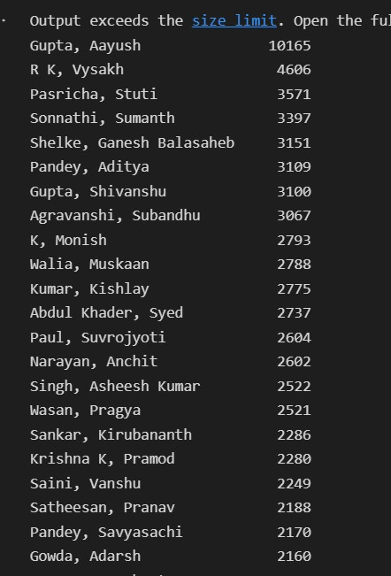

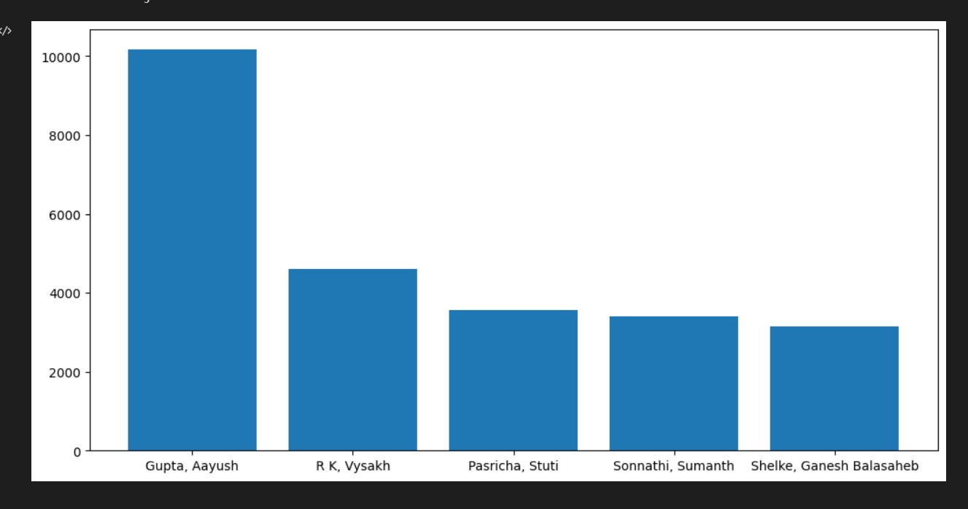

From the above plot and results, we can confirm that the leader is Aayush Gupta with approximately 10% of the total visits.